W3-S3 PRACTICE
CSS SELECTORS & BOX MODEL

 At the end of this practice, you should be able to…
Manipulate CSS basics
• Font and color properties
• Margin, padding, border
• Units (px, %, vh, vw, em)
• Pseudo class (hover, active)

 How to work?
- Download the start code from the LMS
- Open the folder in VS Code

How to submit?
- Push your final code on your GitHub repository
- Then attach the GitHub path to the MS Team assignment and turn it in

 Are you lost?
You can read the following documentation to be ready for this practice:
- Guide - WC3 School
- Guide - Flexbox properties
- Video – Flex in 10 minutes!
- FLEX EXPLORER

EXERCISE 1
Using the CSS attributes, you have learned, build the layout pictured below.

- You need to be as close as possible to the given specification
- All buttons have the same rendering, expect the colors (green, orange, purple)
- You need to avoid code redundancy as much as possible
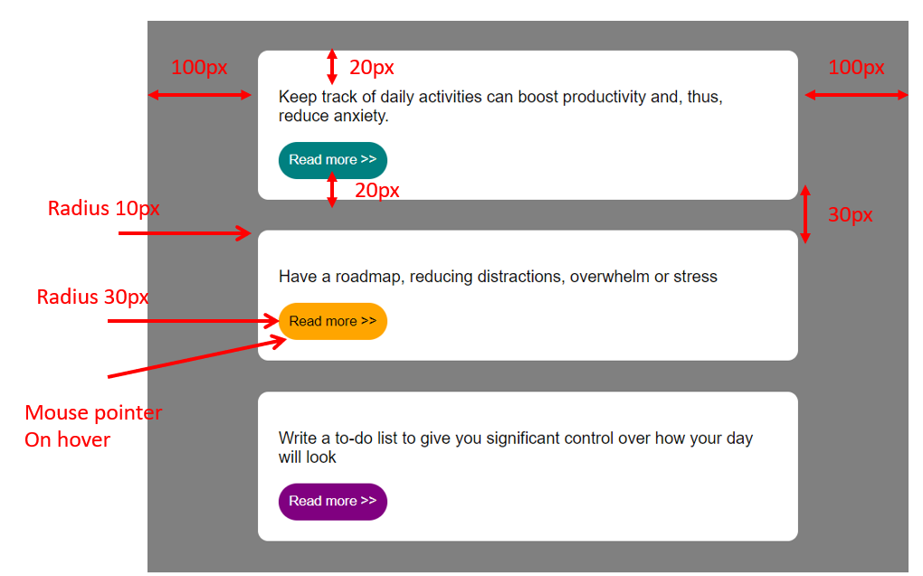

 How to start?
- HTML/CSS start code is provided

 Are you lost?
TIP 1 - Here are the CSS properties involved in this exercise:
- padding, margin, border
- cursor
- color, background, border, border-radius

TIP 1 – Think about the CSS selectors you want to use, in order to avoid code redundancy
    - Element type selectors
    - Class selectors?
    - ID selectors?

EXERCISE 2
You have 8 challenges, and 6 bonus challenges to perform.

- Each challenge consists of writing some CSS code to match with the requirements
- You cannot change the HTML code; you need to do everything in the CSS file

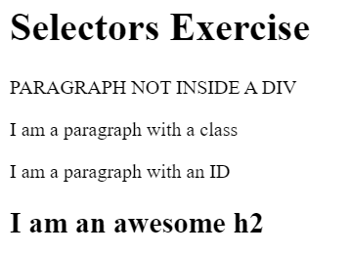

MANDATORY CHALLENGES
Give the <body> element a background of #bdc3c7
Make the <h1> element #9b59b6
Make all <h2> elements orange
Make all <li> elements blue (pick your own hexadecimal blue)
Change the background on every paragraph to be yellow
Make all inputs have a 3px red border
Give everything with the class 'hello' a white background
Give the element with id 'special' a 2px solid blue border (pick your own rgb blue)

BONUS CHALLENGES
Note: You may need to research some other selectors and properties
Make all the <p>'s that are nested inside of divs 25px font(font-size: 25px)
Make only inputs with type 'text' have a gray background
Make all "checked" checkboxes have a left margin of 50px(margin-left: 50px)
Make the <label> elements all UPPERCASE without changing the HTML(definitely look this one up
Make the first letter of the element with id 'special' green and 100px font size(font-size: 100)
Make the <h1> element's color change to blue when hovered over

EXERCISE 3
Write the HTML and the CSS code to comply with the bellow design.
- The button shall change its background and border colors when the mouse is hover

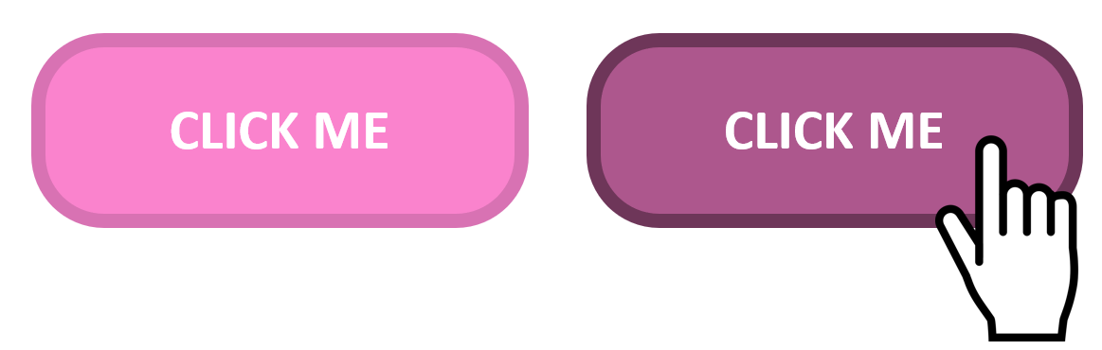

 Are you lost?
TIP 1 – You will need to use the pseudo selector to change the button color when mouse is hover.
https://www.w3schools.com/css/css_pseudo_classes.asp

EXERCISE 4
Design and implement a profile card. This card should include
- a profile picture,
- a name, a short bio
- a button for interaction

Be creative, you can design this profile card your own way !!

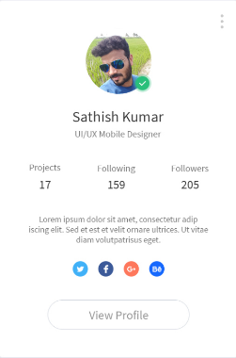
Just an example

HTML
- A div container for the card.
- An image element for the profile picture.
- A heading for the name.
- A paragraph for a short bio.
- A button for interaction (e.g., "Learn More" or "Contact").
CSS
- Use external CSS for the main styling.
- Apply inline or internal CSS for at least one element to demonstrate understanding.
- Use various font and color properties to enhance the card’s appearance.
- Implement Box Model concepts (margin, padding, border) to create a well-spaced layout.
- Create a hover effect for the button.
- Apply a box shadow to give the card a lifted look.

